SCIT, University of Wollongong
CSIT128: Introduction to Web Technology
Assignment 1 (Ice Kachang) – Report
Group T01
Prepared 11 July 2026

Overview

CSS / Styling
A handful of rules at the top of the stylesheet apply everywhere rather than to one part:
body {
margin: 30px;
line-height: 1.5;
}

h1 { text-align: center; font-size: 22px; margin-bottom: 25px; }
h2 { font-size: 18px; margin-top: 30px; margin-bottom: 10px; }
table { border-collapse: collapse; width: 100%; }
.msg { color: red; font-size: 13px; margin-left: 6px; }
.btn { padding: 4px 10px; font-size: 14px; cursor: pointer; }

Do we need explain CSS?

Part 1: Group Information
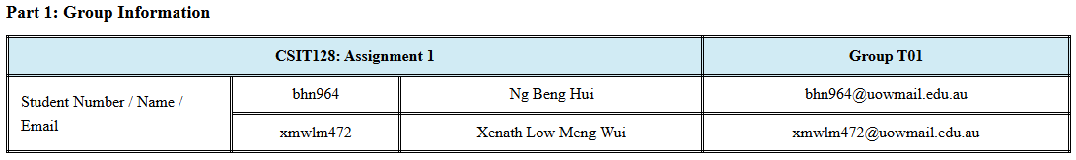
HTML:
<h2>Part 1: Group Information</h2>
<table id="part1">
<tr>
<th colspan="3">CSIT128: Assignment 1</th>
<th>Group T01</th>
</tr>
<tr>
<td class="label" rowspan="2">Student Number / Name / Email</td>
<td>bhn964</td>
<td>Ng Beng Hui</td>
<td>bhn964@uowmail.edu.au</td>
</tr>
<tr>
<td>xmwlm472</td>
<td>Xenath Low Meng Wui</td>
<td>xmwlm472@uowmail.edu.au</td>
</tr>
</table>

CSS:
#part1, th, td {
border-style: double;
}

#part1 th, #part1 td {
text-align: center;
padding: 6px 12px;
}

#part1 th {
background-color: rgba(190, 227, 240, 0.714);
}

#part1 .label {
text-align: left;
width: 200px;
}

Explanation
HTML:
The <th colspan="3"> cell merges three header columns into one. For “CSIT128 Assignment 1”
<td rowspan="2"> on the label cell makes it span 2 member rows.
CSS:
#part1, th, td { border-style: double; } gives cells a double-line border — note this selector is written as three separate selectors (#part1, th, td) rather than one scoped to Part 1, so it currently applies to every table cell on the whole page, not just this one (see Notes).
#part1 th { background-color: rgba(190, 227, 240, 0.714); } tints just the header row,
#part1 .label keeps the label column left-aligned at a fixed 200px width, while #part1 th, #part1 td centres everything else.

Part 2: Hello World in Different Languages
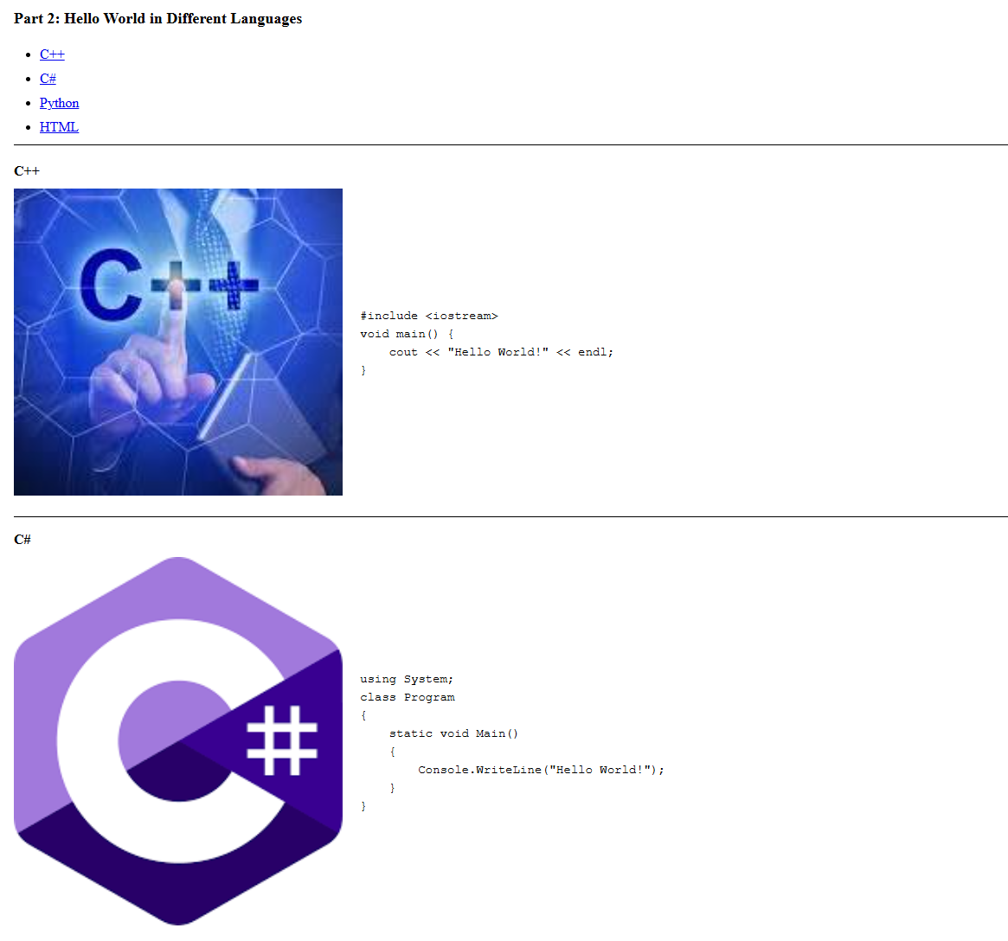
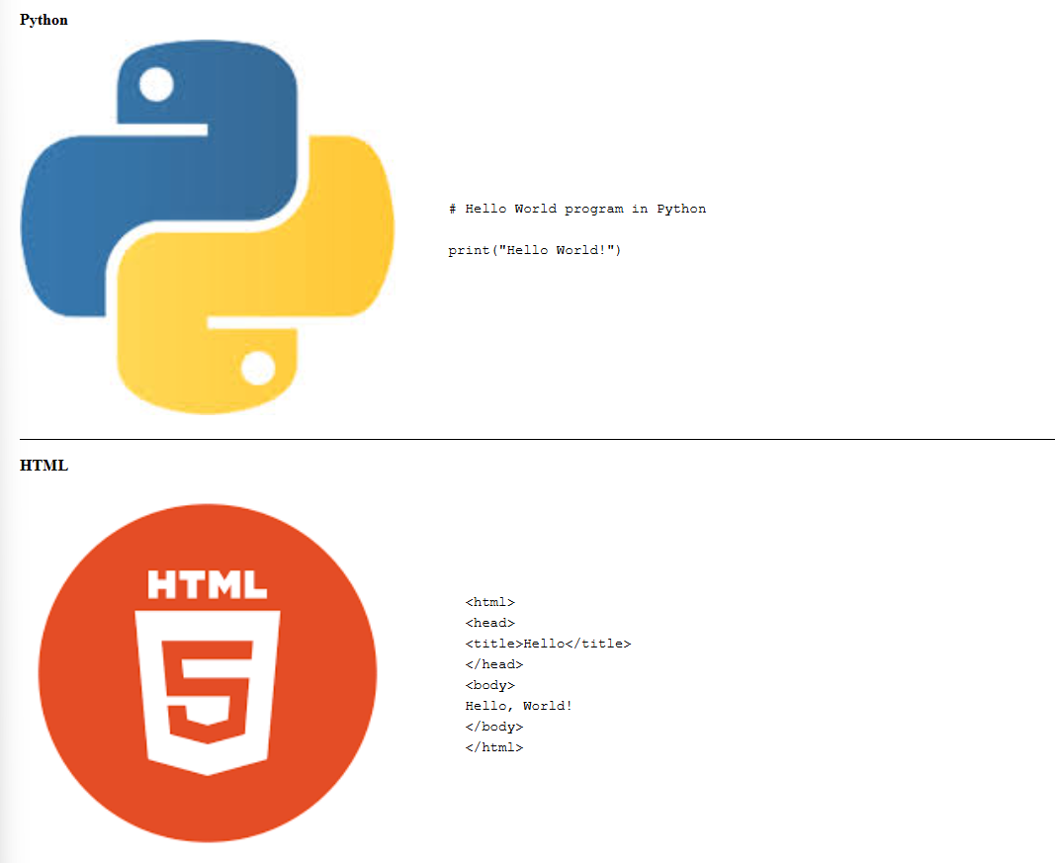

Code
HTML
<ul id="part2-links">
<li><a href="#cpp">C++</a></li>
<li><a href="#cs">C#</a></li>
<li><a href="#python">Python</a></li>
<li><a href="#html">HTML</a></li>
</ul>

<hr class="link-sep">

<div class="lang-section" id="cpp">
<h3>C++</h3>
<div class="lang-body">
<img src="CSIT128-Y202606-A1/CPP.jpg" alt="Hello World in C++">
<pre>#include &lt;iostream&gt;
void main() {
cout &lt;&lt; "Hello World!" &lt;&lt; endl;
}</pre>
</div>
</div>
CSS:
#part2-links { margin-bottom: 8px; padding-left: 30px; list-style-type: disc; }
#part2-links li { margin: 4px 0; }
#part2-links a { text-decoration: underline; color: #0000EE; }

hr.link-sep { border: none; border-top: 1px solid #000; margin: 6px 0 18px 0; }

.lang-section { margin-bottom: 10px; padding-bottom: 10px; }
.lang-section h3 { font-size: 16px; margin: 8px 0; }
.lang-section .lang-body { display: flex; align-items: center; gap: 20px; }
.lang-section img { width: 380px; height: auto; border: none; flex-shrink: 0; }
.lang-section pre { margin: 0; font-family: "Courier New", monospace; font-size: 14px; white-space: pre; padding-top: 4px; }

hr.lang-sep { border: none; border-top: 1px solid #000; margin: 14px 0; }

The four “Hello World” samples
C++:
#include <iostream>
void main() {
cout << "Hello World!" << endl;
}

C#:
using System;
class Program
{
static void Main()
{
Console.WriteLine("Hello World!");
}
}

Python:
# Hello World program in Python

print("Hello World!")

HTML:
<html>
<head>
<title>Hello</title>
</head>
<body>
Hello, World!
</body>
</html>

Explanation
Each list item's href="#cpp" (etc.) is a same-page anchor: clicking it jumps straight to the element whose id="cpp" matches, with no page reload — that id is set on the <div class="lang-section"> for each language.
.lang-body { display: flex; align-items: center; gap: 20px; } arranges the picture and the <pre> code side by side using Flexbox, vertically centred, with an even 20px gap — a newer layout method than older float- or table-based approaches (see Advanced Features).
The <pre> tag preserves the exact spacing and line breaks of each code sample so it displays as typed; inside it, &lt; and &gt; are used instead of literal </> so the browser shows them as text rather than trying to parse them as tags.
Picture sizing is done in CSS (.lang-section img { width: 380px; height: auto; }) rather than as width/height attributes on the <img> tag itself — visually similar, but worth checking against the brief's specific wording (“resize the picture using the image attribute”), which points at the HTML attribute rather than CSS.

Compliance notes
- All four languages are present with working jump links, matching the required behaviour.
- Images use a relative link (CSIT128-Y202606-A1/...) as required, and have no outer border (border: none); the four actual picture files weren't part of this upload, so confirm they're included in the final submission folder.
- Consider whether picture resizing should use the HTML width/height attributes instead of (or alongside) the current CSS rule, per the brief's wording.

Part 3: University Policies and Services
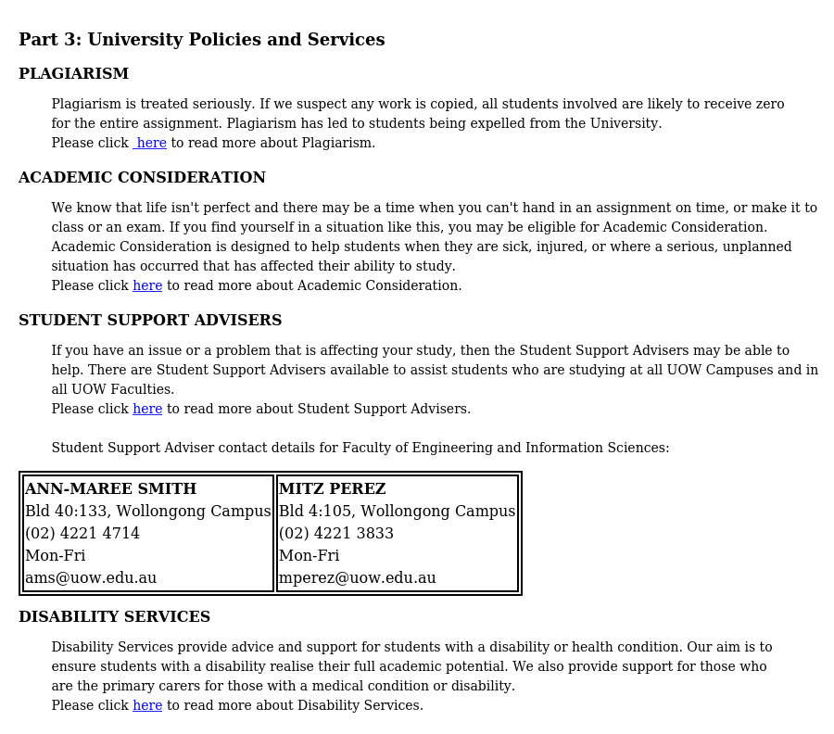

HTML
<h2>Part 3: University Policies and Services</h2>

<div id="part3">
<p><strong>Plagiarism</strong></p>
<pre> Plagiarism is treated seriously. If we suspect any work is copied, all students involved are likely to receive zero
for the entire assignment. Plagiarism has led to students being expelled from the University.
Please click <a href="https://www.uow.edu.au/student/support-services/academic-skills/onlineresources/referencing-and-citing/plagiarism/" target="_blank"> here</a> to read more about Plagiarism.</pre>

<p><strong>Academic Consideration</strong></p>
<pre> We know that life isn't perfect and there may be a time when you can't hand in an assignment on time, or make it to
class or an exam. If you find yourself in a situation like this, you may be eligible for Academic Consideration.
Academic Consideration is designed to help students when they are sick, injured, or where a serious, unplanned
situation has occurred that has affected their ability to study.
Please click <a href="https://www.uow.edu.au/student/admin/academic-consideration/" target="_blank">here</a> to read more about Academic Consideration.</pre>

<p><strong>Student Support Advisers</strong></p>
<pre> If you have an issue or a problem that is affecting your study, then the Student Support Advisers may be able to
help. There are Student Support Advisers available to assist students who are studying at all UOW Campuses and in
all UOW Faculties.
Please click <a href="https://www.uow.edu.au/student/support-services/coordinators/" target="_blank">here</a> to read more about Student Support Advisers.

Student Support Adviser contact details for Faculty of Engineering and Information Sciences:</pre>
<table class="contact">
<tr>
<td><strong>Ann-Maree Smith</strong>
Bld 40:133, Wollongong Campus
(02) 4221 4714
Mon-Fri
ams@uow.edu.au
</td>
<td><strong>Mitz Perez</strong>
Bld 4:105, Wollongong Campus
(02) 4221 3833
Mon-Fri
mperez@uow.edu.au</td>
</tr>
</table>

<p><strong>Disability Services</strong></p>
<pre> Disability Services provide advice and support for students with a disability or health condition. Our aim is to
ensure students with a disability realise their full academic potential. We also provide support for those who
are the primary carers for those with a medical condition or disability.
Please click <a href="https://www.uow.edu.au/about/our-people/diversity-inclusion/people-with-livedexperience-of-disability/" target="_blank">here</a> to read more about Disability Services.</pre>
</div>

CSS
#part3 > p + pre,
#part3 > p + table {
margin-top: 0;
}

#part3 p:has(strong:only-child) {
margin: 0;
display: inline;
}

#part3 p strong,
#part3 strong {
font-family: "Times New Roman", serif;
font-weight: bold;
text-transform: uppercase;
}

#part3 table.contact {
border: 2px solid #000;
border-collapse: separate;
border-spacing: 2px;
width: auto;
margin: 10px 0;
}

#part3 table.contact td {
border: 2px solid #000;
padding: 1px;
vertical-align: top;
font-family: "Times New Roman", serif;
white-space: pre;
}

#part3 pre {
font-family: Georgia, 'Times New Roman', serif;
font-size: 14px;
}

Explanation
<h2></h2> is a HTML header tag which the lower the number the bigger the font size of the text encapsulated it becomes, it is also boldened by default.
<div id="part3"> acts like a container to group all elements.

<p><strong>Plagiarism<strong></p> creates a boldened title for each section. #part3 p:has(strong:only-child) targets any <p> tag inside #part3 that contains the <strong> tag to remove the default margin that is preset and sets display to inline which makes the element sit on top of the text in <pre> with no
spacing. #part3 p strong, #part3 strong this changes the font-style to Times New Roman, boldens the letters and uppercases it.
<pre>...</pre> this tag preserves the formatting of all the characters/whitespaces that are implemented within it. #part3 pre targets all <pre> tags inside #part3 transforming their font type to Times New Roman to fit the requirements.
<a href="url" target="_blank">...</a> creates a clickable hyperlink for the text defined in the tag, href specifies the destination url, while target="_blank" indicates that the specified page will be opened in a new browser tab.
This same format is used consequently for the other sections.

<table class="contact"> creates a table with the class name contact for reference to styling the table. #part3 table.contact targets the tablewith the class contact inside #part3, which styles the element with a 2px solid black border, border-collapse and border-spacing creates the gap between cells. Width auto sizes the table based on the content.
<tr> defines a table row inside the table, each table row tag used constitutes 1 row.
<td>...</td> defines a table column which is used to hold the each of the student adviser’s contact information, each td tag used constitutes 1 column, when used in this example, 1 row consists of 2 columns. #part3 table.contact td targets each column cell with a 2px solid black border, 1px padding to space out the elements from all sides evenly, top-aligned text and preserve line breaks.

Requirements
- Website structure must closely match the sample
- The four links must be used in the relevant sections shown in the sample.
- No outer border is required for the whole section.

Part 4: Form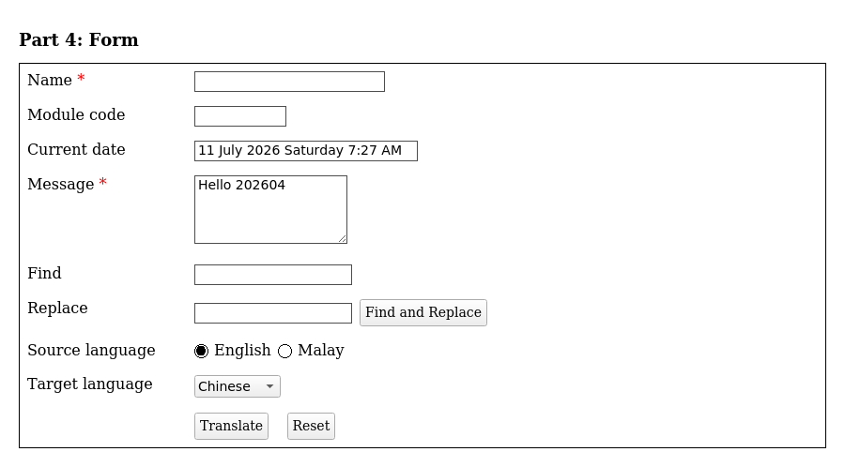

HTML
<form id="part4" onsubmit="return doTranslate();" action="https://translate.google.com" target="_blank">
<table id="part4-form">
<tr>
<td class="label-cell">Name <span style="color:red">*</span></td>
<td>
<input type="text" id="name" size="25">
<span class="msg" id="nameMsg"></span>
</td>
</tr>
<tr>
<td class="label-cell">Module code</td>
<td>
<input type="text" id="module" size="10">
<span class="msg" id="moduleMsg"></span>
</td>
</tr>
<tr>
<td class="label-cell">Current date</td>
<td><input type="text" id="date" size="30" readonly></td>
</tr>
<tr>
<td class="label-cell">Message <span style="color:red">*</span></td>
<td>
<textarea id="message" rows="4" cols="20">Hello 202604</textarea>
<span class="msg" id="messageMsg"></span>
</td>
</tr>
<tr>
<td class="label-cell">Find</td>
<td><input type="text" id="find" size="20" oninput="toggleReplace();"></td>
</tr>
<tr>
<td class="label-cell">Replace</td>
<td>
<input type="text" id="replace" size="20" disabled>
<input type="button" class="btn" value="Find and Replace" onclick="findReplace();">
<span class="msg" id="replaceCount" style="color:green;"></span>
</td>
</tr>
<tr>
<td class="label-cell">Source language</td>
<td>
<label><input type="radio" name="srcLang" value="en" checked> English</label>
<label><input type="radio" name="srcLang" value="ms"> Malay</label>
</td>
</tr>
<tr>
<td class="label-cell">Target language</td>
<td>
<select id="tgtLang">
<option value="zh-CN" selected>Chinese</option>
<option value="ja">Japanese</option>
<option value="ms">Malay</option>
<option value="ko">Korean</option>
</select>
</td>
</tr>
<tr>
<td class="label-cell"></td>
<td>
<input type="submit" class="btn" value="Translate">
&nbsp;
<input type="reset" class="btn" value="Reset" onclick="resetForm(); return false;">
</td>
</tr>
</table>
</form>

CSS
#part4 table { border: 1px solid black; }

#part4-form { width: 100%; border-collapse: collapse; }
#part4-form td { border: none; padding: 6px 8px; vertical-align: top; }
#part4-form .label-cell { width: 160px; font-weight: normal; }

#part4-form input[type="text"],
#part4-form textarea,
#part4-form select {
font-family: Arial, sans-serif;
font-size: 14px;
padding: 2px 4px;
}

#part4-form textarea { resize: vertical; }

Explanation
The whole form sits inside a <table> (id="part4-form") as required, with one row per field; .label-cell fixes the label column at 160px. The required-field asterisks are plain red <span>s, not built-in validation. readonly on the date box lets JavaScript set its value while blocking manual typing; the Replace box starts disabled until Find has text; the Translate button is type="submit" (triggers the form's onsubmit) and Reset is type="reset" with its own onclick.

JavaScript

setTodayDate()
function setTodayDate() {
const months = ["January", "February", "March", "April", "May", "June",
"July", "August", "September", "October", "November", "December"];
const days = ["Sunday", "Monday", "Tuesday", "Wednesday", "Thursday", "Friday", "Saturday"];
const d = new Date();

let h = d.getHours();
const m = d.getMinutes();
const ampm = h >= 12 ? "PM" : "AM";
h = h % 12;
if (h === 0) h = 12;
const mm = m < 10 ? "0" + m : m;

const text = d.getDate() + " " + months[d.getMonth()] + " " + d.getFullYear()
+ " " + days[d.getDay()] + " " + h + ":" + mm + " " + ampm;
document.getElementById("date").value = text;
}

Builds the required “8 April 2026 Wednesday 1:47 PM”-style string from the browser's own clock (the Date object — see Advanced Features) and writes it into the read-only date box. It runs once when the page loads, and again at the end of Reset.

toggleReplace()
function toggleReplace() {
const findTxt = document.getElementById("find").value;
document.getElementById("replace").disabled = findTxt.length === 0;
}

Runs on every keystroke in Find (oninput="toggleReplace();"). Enables Replace once Find has at least one character, disables it again if Find is emptied — matching the requirement exactly.

findReplace()
function findReplace() {
const findTxt = document.getElementById("find").value;
const replTxt = document.getElementById("replace").value;
const msgArea = document.getElementById("message");
const counter = document.getElementById("replaceCount");
const content = msgArea.value;

if (findTxt.length === 0) {
counter.style.color = "red";
counter.textContent = "Please enter text to find.";
return;
}

const count = content.split(findTxt).length - 1;
if (count > 0) {
msgArea.value = content.split(findTxt).join(replTxt);
counter.style.color = "green";
counter.textContent = count + " replacement(s) made.";
} else {
counter.style.color = "red";
counter.textContent = "No match found.";
}
}

Runs when “Find and Replace” is clicked. content.split(findTxt).length - 1 counts how many times Find occurs in Message; split(...).join(replTxt) replaces all of them at once. The count (or an error message) is written beside the button via replaceCount, satisfying the “no popup” rule.

validateName() / validateModule() / validateMessage()
function validateName() {
const nameVal = document.getElementById("name").value;
const nameMsg = document.getElementById("nameMsg");
if (nameVal.length === 0) { nameMsg.textContent = "Name is required."; return false; }
if (!/^[A-Za-z0-9 ]+$/.test(nameVal)) {
nameMsg.textContent = "Only letters, numbers and spaces allowed.";
return false;
}
nameMsg.textContent = "";
return true;
}

function validateModule() {
const modVal = document.getElementById("module").value;
const modMsg = document.getElementById("moduleMsg");
if (modVal.length === 0) { modMsg.textContent = ""; return true; }
if (!/^[A-Z]{4}[4-8]{3}$/.test(modVal)) {
modMsg.textContent = "Format: 4 uppercase letters followed by 3 digits (4-8).";
return false;
}
modMsg.textContent = "";
return true;
}

function validateMessage() {
const msgVal = document.getElementById("message").value;
const msgMsg = document.getElementById("messageMsg");
if (msgVal.trim().length === 0) { msgMsg.textContent = "Message cannot be empty."; return false; }
msgMsg.textContent = "";
return true;
}

Each function checks one field and writes straight into a <span class="msg"> beside it — never a popup. The pattern checks use regular expressions (see Advanced Features): /^[A-Za-z0-9 ]+$/ allows only letters, digits and spaces for Name, and /^[A-Z]{4}[4-8]{3}$/ requires exactly 4 uppercase letters then 3 digits, each between 4 and 8, for Module code (which is optional — an empty value passes automatically).

doTranslate()
function doTranslate() {
const nameOk = validateName();
const modOk = validateModule();
const msgOk = validateMessage();

if (!nameOk || !modOk || !msgOk) return false;

const msgVal = document.getElementById("message").value;
const srcLang = document.querySelector('input[name="srcLang"]:checked').value;
const url = "https://translate.google.com/?sl=" + encodeURIComponent(srcLang)
+ "&tl=" + encodeURIComponent(document.getElementById("tgtLang").value)
+ "&text=" + encodeURIComponent(msgVal);
window.open(url, "_blank");
return false;
}

Runs on form submit (the Translate button). It checks all three fields first; if any fail it returns false and stops. If all pass, it builds a Google Translate URL from the chosen languages and Message text — each piece passed through encodeURIComponent() (see Advanced Features) so special characters can't break the URL — and opens it with window.open(url, "_blank"). It always returns false, so the form's own action="https://translate.google.com" attribute never actually fires; this manual pop-up is what really performs the translation.

resetForm()
function resetForm() {
document.getElementById("name").value = "";
document.getElementById("module").value = "";
document.getElementById("message").value = "Hello 202604";
document.getElementById("find").value = "";
document.getElementById("replace").value = "";
document.getElementById("replace").disabled = true;
document.getElementById("replaceCount").textContent = "";
document.getElementById("nameMsg").textContent = "";
document.getElementById("moduleMsg").textContent = "";
document.getElementById("messageMsg").textContent = "";
document.querySelector('input[name="srcLang"][value="English"]').checked = true;
document.getElementById("tgtLang").selectedIndex = 0;
setTodayDate();
}

Runs when Reset is clicked; clears Name/Module/Find/Replace, restores Message to its default text, disables Replace, and clears the messages. The second-to-last line means to re-check the English radio button, but its selector looks for value="English" while the radio's actual value is "en" (see Notes) — since no element matches, this line throws, and the final two steps (resetting the target-language dropdown and refreshing the date) do not run.

Requirement mapping
Brief requirement | Status | Notes
Name: required, letters/numbers/spaces only | Met
Module code: optional; 4 uppercase letters + 3 digits (4–8) | Met | Note the digit range would reject “CSIT128” itself — confirm this is the intended rule
Current date: read-only, auto-filled, matches the example format | Met
Message: 4 rows × 20 cols, default “Hello 202604”, cannot be empty | Met
Find / Replace boxes; Replace disabled while Find is empty | Met
“Find and Replace” button shows a replacement count beside it | Met
Source language radio: English (default) / Malay | Met
Target language list: Chinese (default), Japanese, Malay, Korean | Met
“Translate” submit button invokes Google Translate | Met
“Reset” button resets all elements | Partially met | Script error part-way through means the language/date reset steps are skipped — see Notes
Validation messages appear beside elements, not as popups | Met

Summary — Before You Submit
- Rename the folder / html file / report to the required convention with your real UOW IDs and names, and confirm whether a tutorial-group prefix (like the brief's own “G2” example) is expected.
- Fill in member 2's real student number and email; add or remove the third table row to match your actual group size.
- Update the page's <title> to match your real names.
- Double-check whether picture resizing should use the HTML width/height attribute rather than the current CSS rule.
- Fix the Reset button: change the radio-selector value from “English” to “en” so all of Reset's steps run.
- Confirm the module-code digit range (4–8) is what your course wants, since it currently excludes the unit's own code, “CSIT128.”
- Add the four real pictures at the relative paths the code expects, then re-capture screenshots for the final report.
- Consider scoping #part1, th, td { border-style: double; } to Part 1 only, unless the page-wide double border on every table is intended.

Happy to adjust the structure, tighten the wording, fix any of the flagged items directly in the HTML, or regenerate the screenshots once the real images and names are in — just let me know.

